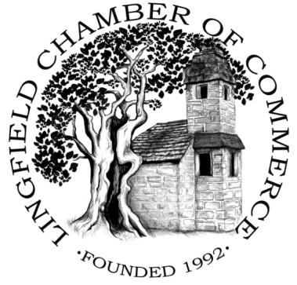
LINGFIELD DAY 2021
CHRISTMAS STALLS – BOOKING FORM
SATURDAY 4TH DECEMBER (15:00 – 19:00)

NAME (Business): (Owner):
ADDRESS: TEL:
E-MAIL: WEBSITE:
TRADING CATEGORY:
GOODS (examples):
DONATION OFFERED (suggested minimum £25 per 3m space): £________
PUBLIC LIABILITY INSURANCE REQUIRED (please select from the following):
- (non hot-food stalls at £10) £________
- (hot-food stalls at £32) £________
- (I have my own Public Liability Insurance and attach a copy of the certificate)

Total payment: £________
PREFERRED LOCATION: please tick (subject to amendment and availability)
High Street ___Community Centre ___Victoria Sports & Social Club ___
Terms & Conditions:
- The event organiser is Lingfield Chamber of Commerce
- Lingfield Chamber of Commerce accepts no liability whatsoever for any:
  - actual or perceived damage or loss to any stall holder, goods or their equipment during the event, or
  - actual or consequential loss in the event of cancellation. Stallholders will be notified in advance, if possible.
- All stallholders must be in the designated location and set up by 15:00. Access will be available from 13:30.
- All stallholders are discouraged from leaving the event before 19:00. Access will be available until 20:00.
- Traders’ licences will be paid by the organisers, however for compliance a list of High Street traders must be provided to Tandridge District Council (via the Chamber) prior to 4th November 2020.
- No payment is demanded from local businesses, however donations are gratefully received to cover our costs. A guideline price is minimum £25 per table. Receipt will be e-mailed.
- Evidence of Public Liability Insurance will be required at time of booking.

To reserve a space or for further information, please email:
lingfieldevents@gmail.com or charlie_pilkington@hotmail.com
Donation Payment Online:
Account – Lingfield Chamber of Commerce Christmas Lights Fund
Sort Code: 20-23-97 Account Number: 93905993

